James Liu

CS 4495, Computer Vision

Fall 2014

Problem Set 3

**Problem Set 3, Question 1, Part 1**

M =

-0.4583 0.2947 0.0140 -0.0040

0.0509 0.0546 0.5410 0.0524

-0.1090 -0.1784 0.0443 -0.5968

Residual of the last point’s projection: 0.0245

**Problem Set 3, Question 1, Part 2**

|  |  |  |  |
| --- | --- | --- | --- |
| Trial | K = 8 | K = 12 | K = 16 |
| 1 | 3.02642800641653 | 1.28247364682852 | 4.44151913242835 |
| 2 | 2.45691826116276 | 4.63992675770143 | 0.211652221525655 |
| 3 | 0.674655060628898 | 1.75731233335290 | 1.38339515462800 |
| 4 | 59.3142611510472 | 251.864531468462 | 0.595385847345964 |
| 5 | 1.21865957882760 | 3.20434376184088 | 2.44680431723205 |
| 6 | 1.83693527626231 | 1.40015723146659 | 2.04305013110626 |
| 7 | 2.70209667671853 | 29.3452215149362 | 3.64380592823140 |
| 8 | 3.16732366195499 | 2.39994700894999 | 2.83171925869810 |
| 9 | 1.45071111828063 | 2.53126851333089 | 0.303455256908579 |
| 10 | 2.62288290737476 | 0.382398544097618 | 3.15390024990645 |
| Average | 7.84708717 | 29.88075808 | 2.10546875 |
| Standard Deviation | 18.10230643 | 78.47086548 | 1.460829348 |

Minimum highlighted in yellow.

As k increases, the amount of information that is provided when constructing the model (in this case, the M matrix) also increases, which in turn decreases the likelihood that outliers and noise will strongly affect the final result. Two notable examples are the trials highlighted in green. As the selection of points is random, there is a chance that a certain subset of the points would portray a very erroneous model, and the likelihood of this decreases as k increases, as the k=16 trials had no such outlier.

BestM =

0.0069 -0.0040 -0.0013 -0.8263

0.0016 0.0010 -0.0073 -0.5630

0.0000 0.0000 -0.0000 -0.0034

**Problem Set 3, Question 1, Part 3**

C = < 303.0978, 307.1863, 30.4224>

**Problem Set 3, Question 2, Part 1**

F =

|  |  |  |
| --- | --- | --- |
| -6.60675943527704e-07 | 8.82674943996016e-06 | -0.000908539064346732 |
| 7.90642196963890e-06 | 1.21863595933972e-06 | -0.0264201800598200 |
| -0.00188480992014533 | 0.0172276843475569 | 1 |

**Problem Set 3, Question 2, Part 2**

F =

|  |  |  |
| --- | --- | --- |
| -5.35615531823631e-07 | 8.83379370514629e-06 | -0.000908085461589477 |
| 7.89578155620912e-06 | 1.21741311011671e-06 | -0.0264069904614202 |
| -0.00188386904042541 | 0.0172190838601108 | 0.999500775528400 |

**Problem Set 3, Question 2, Part 3**

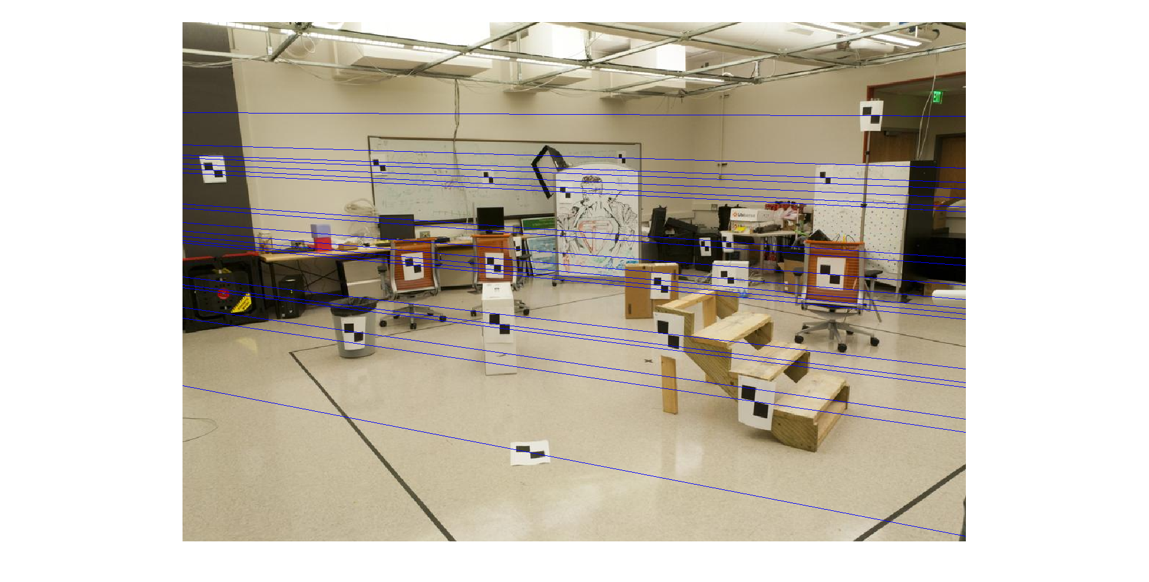

Epipolar lines drawn on Image A using the non-reduced fundamental matrix.

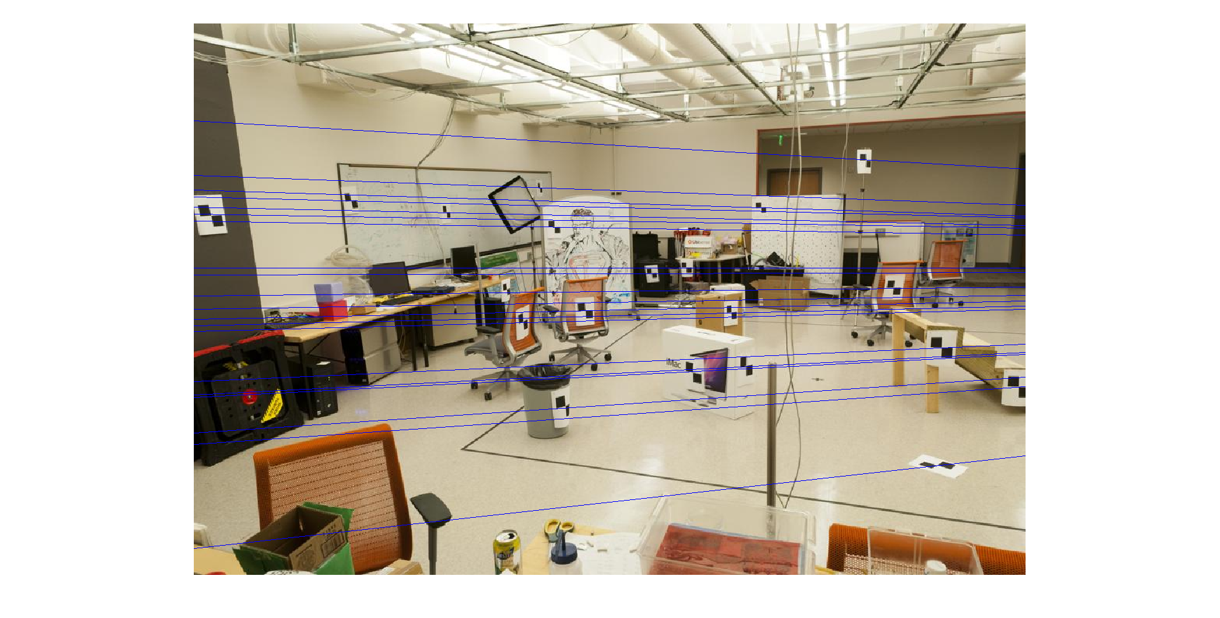

Estimated epipolar lines drawn on Image B using the non-reduced fundamental matrix.

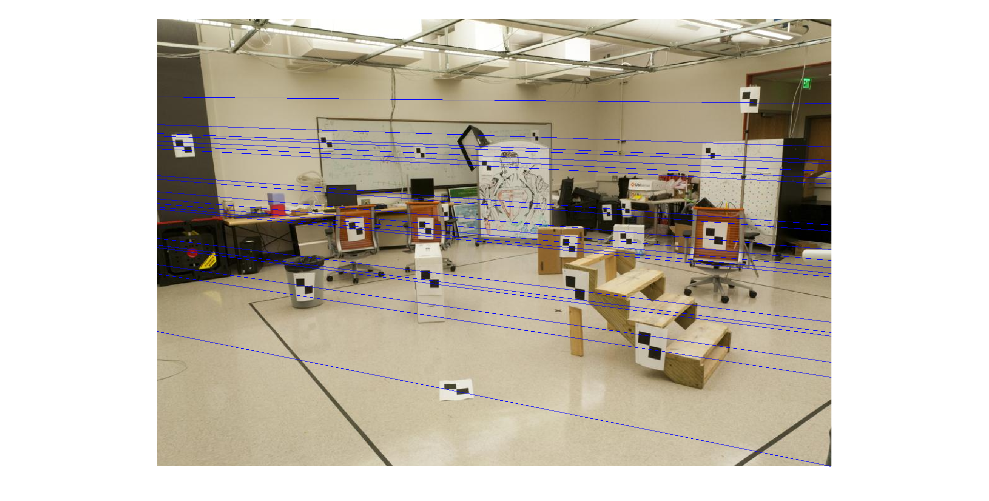

Estimated epipolar lines drawn on Image A using the reduced fundamental matrix. Note how some of the lines are not coincident with the points they originated from.

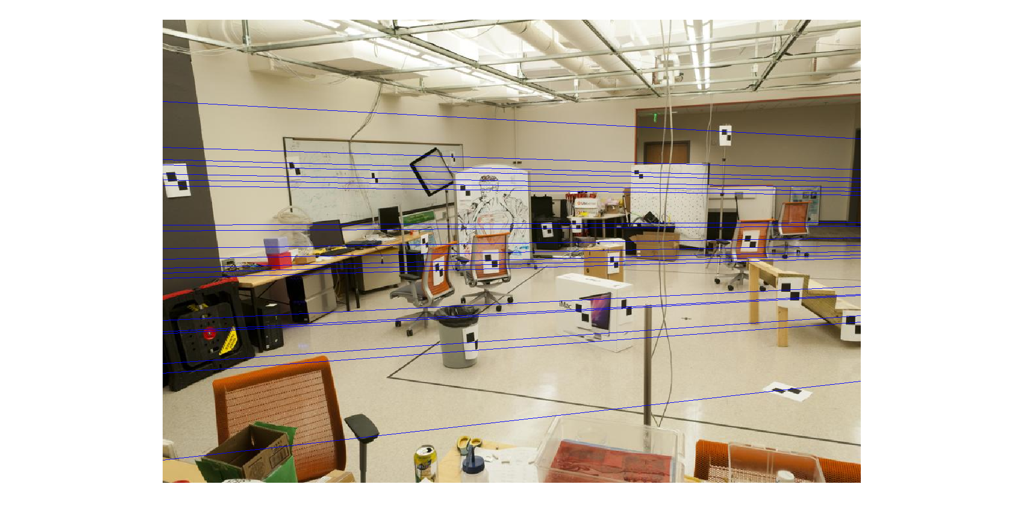

Estimated epipolar lines drawn on Image B using the reduced fundamental matrix. Note how some of the lines are not coincident with the points they originated from.